**Day 4**

1. **What is OSI Model ?**

The Open Systems Interconnection (OSI) model describes seven layers that computer systems use to communicate over a network. It was the first standard model for network communications, adopted by all major computer and telecommunication companies in the early 1980s

The modern Internet is not based on OSI, but on the simpler TCP/IP model. However, the OSI 7-layer model is still widely used, as it helps visualize and communicate how networks operate, and helps isolate and troubleshoot networking problems.

OSI was introduced in 1983 by representatives of the major computer and telecom companies, and was adopted by ISO as an international standard in 1984.

* **OSI Model Explained: The OSI 7 Layers**

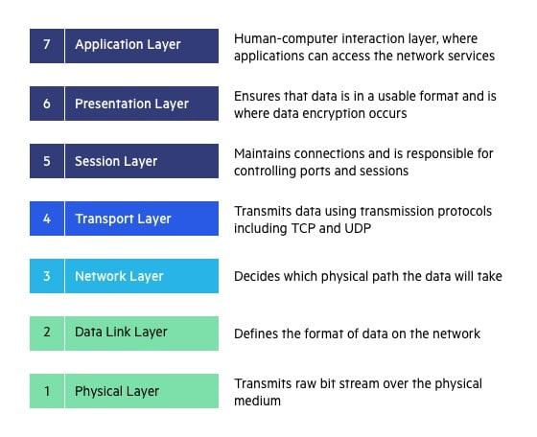

1. **What is TCP/IP ?**

TCP/IP stands for Transmission Control Protocol/Internet Protocol. It has 5 layers named as Physical layer, Network layer, Transport layer, and Application layer.  It also can be used as a communications protocol in a private computer network. It was designed by Vint Cerf and Bob Kahn in the 1970s.

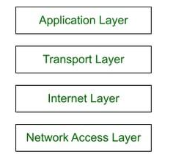

1. **OSI VS TCP/IP MODEL**

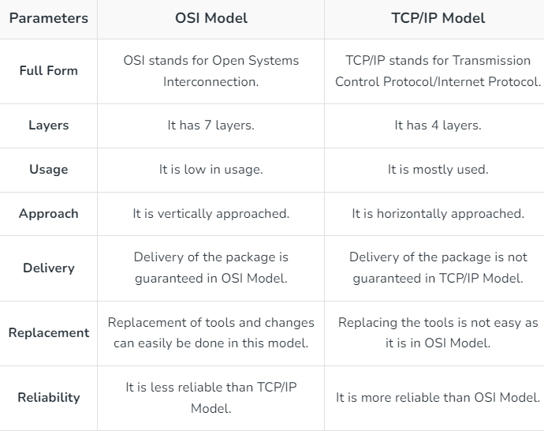

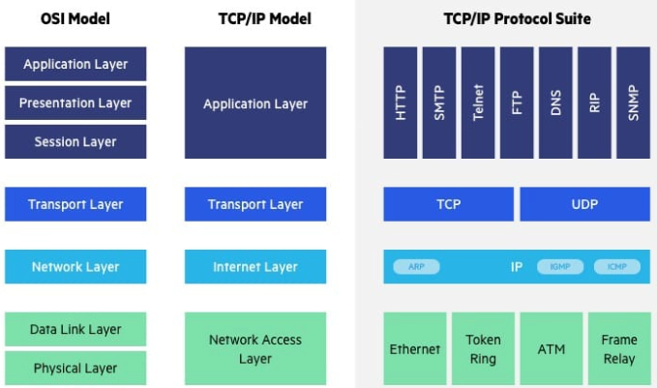

1. **Layer 7 Service and Port number.**

The topmost layer of the OSI model is the application layer. On computer systems, applications display information to the user via the UI.

For example, the user can craft messages and access the network from the application layer. A web browser application allows a user to access a web page. The user may input information and receive information through the web browser. However, the application layer protocol HTTP performs the network communication function. The web browser and HTTP work closely together, and the distinction between the two may be subtle. Yet, HTTP is the web browsing protocol for all web browser applications. In contrast, no single web browser software exclusively utilizes HTTP.

HTTP is one of many common application layer protocols. Below are a few additional protocols to know. It is also good practice to memorize the associated port assigned to the protocols:

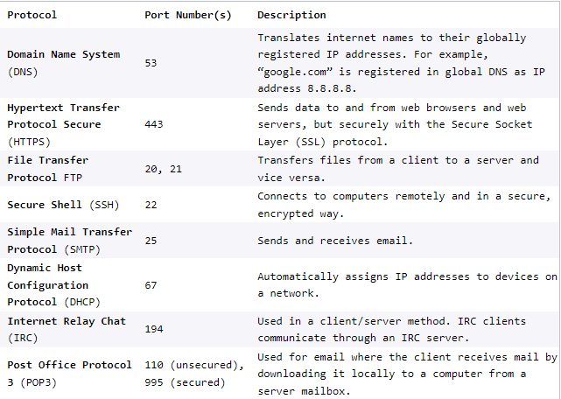

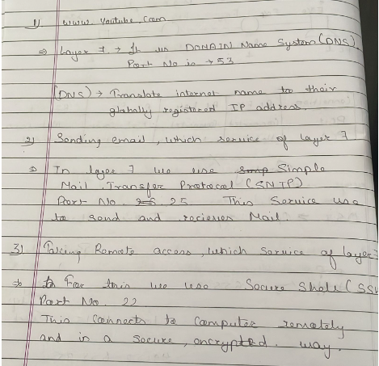

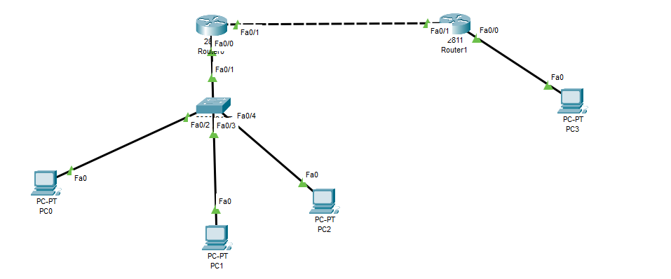

**Solution**

